WildRoute – QA Testing Screenshots.

1. WR-BUG-001 – Layout issue between logo and Back to Expeditions.

WR-BUG-001.

3. WR-BUG-003 – WildRoute text cropped in footer.
WR-BUG-003
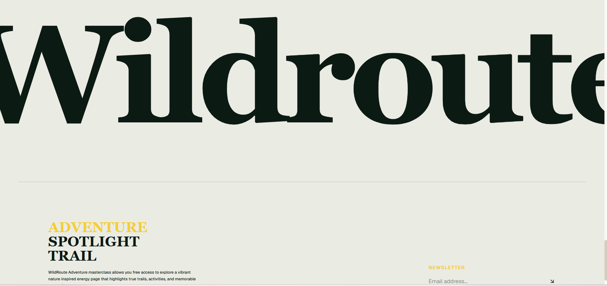
4. WR-BUG-004 – No result after newsletter submission.
WR-BUG-004
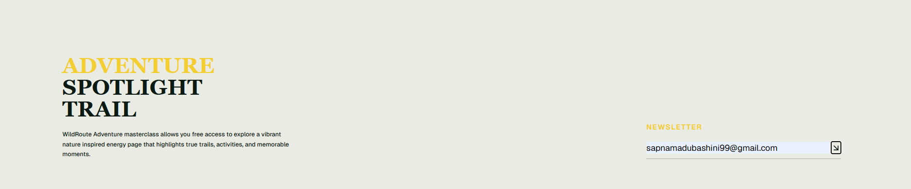

5. WR-BUG-005 – Navigation menu text cropped.
WR-BUG-005

